Mechatronics System Integration (MCTA3203)
Week 4: Serial interfacing with microcontroller: Sensors and actuators (ver. 3.0).

Designing a Motion-Activated RFID System

Learning Objectives
By completing this lab, students will be able to:
- Interface an MPU6050 sensor and RFID module with an Arduino.
- Process real-time accelerometer data using Python.
- Detect simple motion patterns (e.g., circular motion).
- Integrate motion sensing and RFID authentication to control a servo-based access system.
- Communicate between Python and Arduino over serial.

Part 1: Interactive Motion Detection with MPU6050

Goal
Establish a bidirectional serial connection where the Arduino constantly streams MPU6050 accelerometer data to Python. Python will analyze the data points in real-time to determine if the user is moving the sensor in a circular motion. If a circle is detected, Python will send a command back to the Arduino to toggle an LED ON or OFF.

Hardware Required
- Arduino board + USB cable
- MPU6050 sensor
- Jumper wires/breadboard
- 1x LED (Any color)
- 1x 220 Ω Resistor
- Computer with Arduino IDE and Python installed

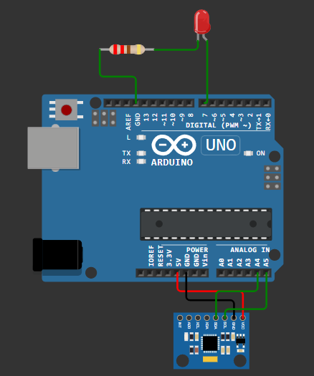
Fig. 1: Arduino-MPU6050 Connections

Connections
MPU6050 Pin | Arduino Uno
VCC | 5V
GND | GND
SDA | A4
SCL | A5
LED PIN
LED | D7
220 ohm | GND

Arduino Code to Read MPU6050 Data:
(This sends accelerometer and gyroscope data over serial at 9600 baud.)

Task 1.1: Arduino Code (Data Stream & Hardware Control)
Your task:
- Capture real-time accelerometer X-Y data.
Arduino Code:
#include <Wire.h>
#include <MPU6050.h>

MPU6050 mpu;

// --- DEFINE YOUR LED PIN HERE ---
const int ledPin = 7; // Fill in

void setup() {
Serial.begin(9600);
Wire.begin();
mpu.initialize();

if (!mpu.testConnection()) {
Serial.println("MPU6050 connection failed!");
while (1);
}

pinMode(ledPin, OUTPUT);
digitalWrite(ledPin, LOW); // Start with LED off
}

void loop() {
// 1. Read motion data
int16_t ax, ay, az, gx, gy, gz;
mpu.getMotion6(&ax, &ay, &az, &gx, &gy, &gz);

// 2. Send formatted data to Python (ax,ay,az)
Serial.print(ax); Serial.print(',');
Serial.print(ay); Serial.print(',');
Serial.println(az);

// 3. Listen for commands from Python to control the LED
if (Serial.available() > 0) {
char cmd = Serial.read();
if (cmd == 'O') {
digitalWrite(ledPin, HIGH); // Turn LED ON
}
else if (cmd == 'F') {
digitalWrite(ledPin, LOW); // Turn LED OFF
}
}

delay(50); // Small delay for stability
}
Click the Serial Monitor and you will see this:
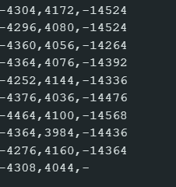

This means that the MPU is capturing raw data.

Task 1.2: Python Script (Motion Detection & Debouncing)
Your task:
- Use python to detect circular motion to light up the LED.
- You could adjust the parameters to ensure smooth movement detection.
- Use any motion other than circular motion (optional).

Python Code:
Note: You must replace 'COMx' with your port
import serial
import time
from collections import deque

# -- Replace 'COMx' with your Arduino's serial port
SERIAL_PORT = 'COMx'
BAUD_RATE = 9600

# Buffers to store the last 40 data points (approx. 2 seconds of motion)
history_x = deque(maxlen=40)
history_y = deque(maxlen=40)

def is_circular_motion(x_data, y_data):
"""
Analyzes an array of X and Y accelerometer data.
Returns True if the data represents a circular motion, False otherwise.
"""
if len(x_data) < 10:
return False

# --- STUDENTS: ADD YOUR CIRCLE DETECTION MATH HERE ---

# Step 1: Find the center (mean) of the X and Y movement.

# Step 2: Check Amplitude. Calculate the variance to ensure there is
# enough overall movement (ignore small jitters).

# Step 3: Check Symmetry. Check the ratio of X standard deviation to Y
# standard deviation to ensure it is round, not a straight line.

# Step 4: Check Continuous Rotation. Use the 2D Cross Product (x1*y2 - y1*x2)
# between consecutive centered points to see which way the path is turning.

# Step 5: Tally the clockwise vs. counter-clockwise turns. If the movement
# is consistently turning in one direction (e.g., > 70%), return True!

return False # Change this to return True when your math detects a circle

def main():
ser = serial.Serial(SERIAL_PORT, BAUD_RATE, timeout=1)
time.sleep(2) # Wait for Arduino to reset
print("System ready. Move the MPU6050 in a circle to toggle the LED...")

# Keep track of the LED state
led_is_on = False

try:
while True:
raw = ser.readline().decode(errors='ignore').strip()
if raw:
parts = raw.split(',')

if len(parts) >= 3:
try:
ax = int(parts[0])
ay = int(parts[1])

# Add new data to our buffers
history_x.append(ax)
history_y.append(ay)

# Only analyze if our buffer is full (40 points)
if len(history_x) == 40:
if is_circular_motion(history_x, history_y):

# Toggle the state
led_is_on = not led_is_on

if led_is_on:
print("Circle Detected! Toggling LED: ON")
ser.write(b'O')
else:
print("Circle Detected! Toggling LED: OFF")
ser.write(b'F')

# DEBOUNCE: Clear the buffers!
# Forces the system to wait for 2 full seconds of
# NEW data before it can trigger another toggle.
history_x.clear()
history_y.clear()

except ValueError:
pass # Ignore corrupted serial lines

except KeyboardInterrupt:
print("\nProgram terminated by user.")
finally:
ser.write(b'F') # Ensure LED turns off when script stops
ser.close()
print("Serial connection closed.")

if __name__ == "__main__":
main()}

Part 2: Introduction to RFID Integration
Goal
Understand how to interface a USB RFID scanner with Python and use it to control external hardware via serial communication. Python will read the scanned card's Unique ID (UID) and, if it matches an authorized list, send a command to the Arduino to turn on an LED for 3 seconds.
Hardware Required:
- Arduino board + USB cable
- USB RFID Scanner + RFID tags/cards
- 1x LED (Any color)
- 1x 220 Ω Resistor
- Jumper wires and breadboard
Circuit Configuration
- Connect the USB RFID Scanner directly to your computer's USB port.
- On your breadboard, connect the Anode (long leg) of the LED to a digital pin on the Arduino.
- Connect the Cathode (short leg) to the 220 Ω resistor, and route the other end of the resistor to Arduino GND.

Task 2.1: Arduino Code (Hardware Slave)
The Arduino's only job in this task is to listen for simple text commands from Python. If it receives a '1', it turns the LED on. If it receives a '0', it turns the LED off.
Note: You must define your own LED pin!
Arduino Code:
// --- DEFINE YOUR LED PIN HERE ---
const int ledPin = ; // Fill in

void setup() {
Serial.begin(9600);
pinMode(ledPin, OUTPUT);
digitalWrite(ledPin, LOW); // Start with LED OFF
}

void loop() {
// Listen for commands from Python
if (Serial.available() > 0) {
char cmd = Serial.read();

if (cmd == '1') {
digitalWrite(ledPin, HIGH); // Turn LED ON
}
else if (cmd == '0') {
digitalWrite(ledPin, LOW); // Turn LED OFF
}
}
}

Task 2.2: Python Script (RFID Master)
Because the USB RFID scanner acts like a keyboard, we can capture its data using Python's basic input() function.
Note: Before running this final code, open a blank Notepad file and scan your RFID card. Copy the 10-digit number that appears and paste it into the AUTHORIZED_CARD variable below. Do not forget to update your COM port!

Python Script:
import serial
import time
# --- CONFIGURATION ---
# Replace 'COMx' with your Arduino's serial port
SERIAL_PORT = 'COM7'
BAUD_RATE = 9600
# Fill in your card's unique 10-digit ID number here
AUTHORIZED_CARD = ("0013084287")
def main():
# Establish connection with the Arduino
arduino = serial.Serial(SERIAL_PORT, BAUD_RATE, timeout=1)
time.sleep(2) # Wait for Arduino to reset
print("RFID System Ready.")
print("Scan a card to test the system. Press CTRL+C to stop.")
try:
while True:
# The USB scanner types the UID and hits Enter automatically.
# input() pauses the script and waits for this to happen.
uid = input("\nTap card: ").strip()
if uid == AUTHORIZED_CARD:
print(f"[{uid}] - Card Authorized! Turning LED ON...")
arduino.write(b'1') # Send ON command to Arduino
time.sleep(3) # Keep LED on for 3 seconds
arduino.write(b'0') # Send OFF command
print("LED OFF. Ready for next scan.")
else:
print(f"[{uid}] - Unauthorized Card! LED remains OFF.")
except KeyboardInterrupt:
print("\nExiting program.")
finally:
# Ensure the LED is safely turned off when the program closes
arduino.write(b'0')
arduino.close()
print("Serial connection closed.")
if __name__ == "__main__":
main()

Note: Click on next to the “Tap card:” before tapping the RFID onto the reader.

Part 3: RFID + Servo Access System

Goal
Combine the USB RFID reader, MPU6050, Servo Motor, and LEDs to build a complete two-factor access control system. Python will act as the master controller, reading the RFID and performing the mathematical motion verification. The Arduino will act as the hardware controller, locking/unlocking the servo and providing LED feedback.

Hardware Required:
- Arduino board + USB cable
- MPU6050 sensor (Keep the I2C wiring from Part 1)
- USB RFID Scanner + RFID tags/cards
- 1x Servo Motor (SG90)
- 1x Green LED & 1x Red LED
- 2x 220 Ω Resistors
Task 3: Integrated Smart Access System

You must build a working system that:
- Scans RFID tag
- Checks if UID is authorized
- Prompts user to perform a circular motion
- Analyzes MPU6050 motion data (if motion detected: send 'A'; otherwise: send 'D')
- Controls servo + LEDs based on result

Circuit Assembly:
- Servo Motor: Connect Signal to D6, VCC to 5V, and GND to GND.
- Green LED (Authorized): Connect Anode to D5, Cathode to GND via 220Ω resistor.
- Red LED (Unauthorized): Connect Anode to D7, Cathode to GND via 220Ω resistor.

Circuit Connection:
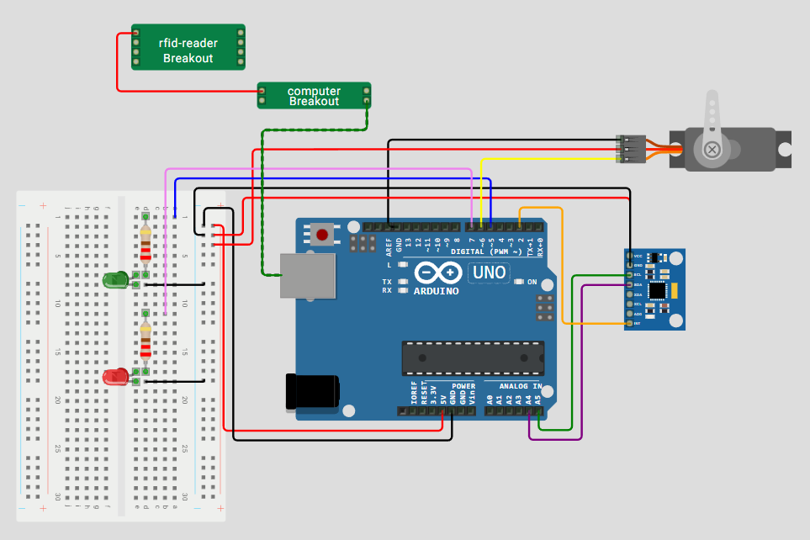

Note: There might be slight mistakes in this connection, do troubleshoot.

System Behavior
Condition | Action
Valid RFID + correct motion | Servo unlocks, green LED on
Invalid RFID OR incorrect motion | Access denied, red LED on

Arduino Code:

#include <Wire.h>
#include <MPU6050.h>
#include <Servo.h>

MPU6050 mpu;
Servo gateServo;

const int greenLedPin = 5;
const int servoPin = 6;
const int redLedPin = 7;

const unsigned long streamDurationMs = 2000; // Stream data for 2 seconds
const unsigned long sampleDelayMs = 50; // 20 Hz sample rate

void setup() {
pinMode(greenLedPin, OUTPUT);
pinMode(redLedPin, OUTPUT);

gateServo.attach(servoPin);
gateServo.write(90); // Start at closed position

Serial.begin(9600);
Wire.begin();
mpu.initialize();

if (!mpu.testConnection()) {
Serial.println(“MPU6050 connection failed!”);
while (1);
}

// Default state: red LED ON (idle/unauthorized)
digitalWrite(redLedPin, HIGH);
digitalWrite(greenLedPin, LOW);
}

void openGate() {
for (int pos = 90; pos <= 180; pos += 2) {
gateServo.write(pos);
delay(15);
}
Serial.println(“Servo opened (90 -> 180)”);
}

void closeGate() {
for (int pos = 180; pos >= 90; pos -= 2) {
gateServo.write(pos);
delay(15);
}
Serial.println(“Servo closed (180 -> 90)”);
}

void wrongCardFlash() {
digitalWrite(redLedPin, HIGH);
digitalWrite(greenLedPin, LOW);
delay(100);
// Blink red LED 3 times
for (int i = 0; i < 3; i++) {
digitalWrite(redLedPin, HIGH);
delay(150);
digitalWrite(redLedPin, LOW);
delay(150);
}
digitalWrite(redLedPin, HIGH); // Return to idle red ON
}

void loop() {
if (Serial.available()) {
char cmd = Serial.read();

if (cmd == ‘1’) {
// Access granted
digitalWrite(greenLedPin, HIGH);
digitalWrite(redLedPin, LOW);
openGate();
}
else if (cmd == ‘0’) {
// System disarmed (Lock)
digitalWrite(greenLedPin, LOW);
digitalWrite(redLedPin, HIGH);
closeGate();
}
else if (cmd == ‘X’) {
// Wrong card feedback
wrongCardFlash();
}
else if (cmd == ‘R’) {
// Python requested motion data
unsigned long start = millis();
while (millis() – start < streamDurationMs) {
int16_t ax, ay, az, gx, gy, gz;
mpu.getMotion6(&ax, &ay, &az, &gx, &gy, &gz);

Serial.print(ax); Serial.print(‘,’);
Serial.print(ay); Serial.print(‘,’);
Serial.print(az); Serial.print(‘,’);
Serial.print(gx); Serial.print(‘,’);
Serial.print(gy); Serial.print(‘,’);
Serial.println(gz);

delay(sampleDelayMs);
}
}
}
}

Python Script for Access Control:

import serial
import time
import math

# --- CONFIGURATION ---
SERIAL_PORT = “COMx” # Update with your Arduino port
BAUD_RATE = 9600
AUTHORIZED_ID = “YOUR_10_DIGIT_ID_HERE”
# ---------------------

def detect_circle(rduino):
“””
Asks Arduino to stream a burst of MPU data, calculates the rotation angles,
and decides whether a circular motion happened.
“””
print(“\n[!] Requesting samples from Arduino… Move in a circle NOW!”)
rduino.reset_input_buffer()
rduino.write(b’R’) # Trigger Arduino data stream

points = []
start_time = time.time()
timeout = 3.0

# Read until timeout (Arduino stops streaming automatically after 2s)
while time.time() – start_time < timeout:
raw = rduino.readline().decode(errors=’ignore’).strip()
if not raw:
continue

parts = raw.split(‘,’)
if len(parts) >= 6:
try:
ax = int(parts[0])
ay = int(parts[1])
az = int(parts[2])
points.append((ax, ay, az))
except ValueError:
continue

print(f”Collected {len(points)} samples.”)
if len(points) < 8:
print(“Not enough motion data – try moving more continuously.”)
return False

# Build angles from (ax, ay) and unwrap to follow continuous rotation
angles = [math.degrees(math.atan2(p[1], p[0])) for p in points]

unwrapped = [angles[0]]
for a in angles[1:]:
prev = unwrapped[-1]
diff = a – prev

# Unwrap angles to avoid -180/180 discontinuity leaps
if diff > 180:
diff -= 360
elif diff < -180:
diff += 360
unwrapped.append(prev + diff)

# Compute net rotation and range
net_rotation = unwrapped[-1] – unwrapped[0]
rotation_range = max(unwrapped) – min(unwrapped)

print(f”Net rotation: {net_rotation:.1f}°, Range: {rotation_range:.1f}°”)

# Lenient detection logic (either a decent net rotation OR wide range)
if abs(net_rotation) > 100 or rotation_range > 140:
print(“ Circle gesture detected!”)
return True

# Extra check: count direction-consistent large angle deltas
deltas = [unwrapped[i+1] – unwrapped[i] for i in range(len(unwrapped)-1)]
large_moves = sum(1 for d in deltas if abs(d) > 10)

if large_moves >= max(6, len(points)//4):
print(“ Motion had multiple consistent movements – accepting as circle.”)
return True

print(“ Motion insufficient. Try a clearer circular motion.”)
return False

def main():
rduino = serial.Serial(SERIAL_PORT, BAUD_RATE, timeout=1)
time.sleep(2) # Wait for Arduino to reset
print(“System Ready. Waiting for RFID…”)

armed = False # System starts locked

try:
while True:
# USB RFID acts as a keyboard
card = input(“\nTap card: “).strip()

if card == AUTHORIZED_ID:
armed = not armed # Toggle state

if armed:
print(“Card Accepted – Please perform circular motion verification!”)

if detect_circle(rduino):
print(“Gesture OK -> System UNLOCKED (LED Green)”)
rduino.write(b’1’)
else:
print(“Wrong gesture -> Try again!”)
armed = False # Revert state if gesture fails
else:
print(“System Disarmed -> System LOCKED (LED Red)”)
rduino.write(b’0’)

else:
print(“WRONG CARD -> Access Denied”)
rduino.write(b’X’)

except KeyboardInterrupt:
print(“\nExiting.”)
finally:
rduino.write(b’0’) # Ensure locked on exit
rduino.close()

if __name__ == “__main__”:
main()

It should look like this:
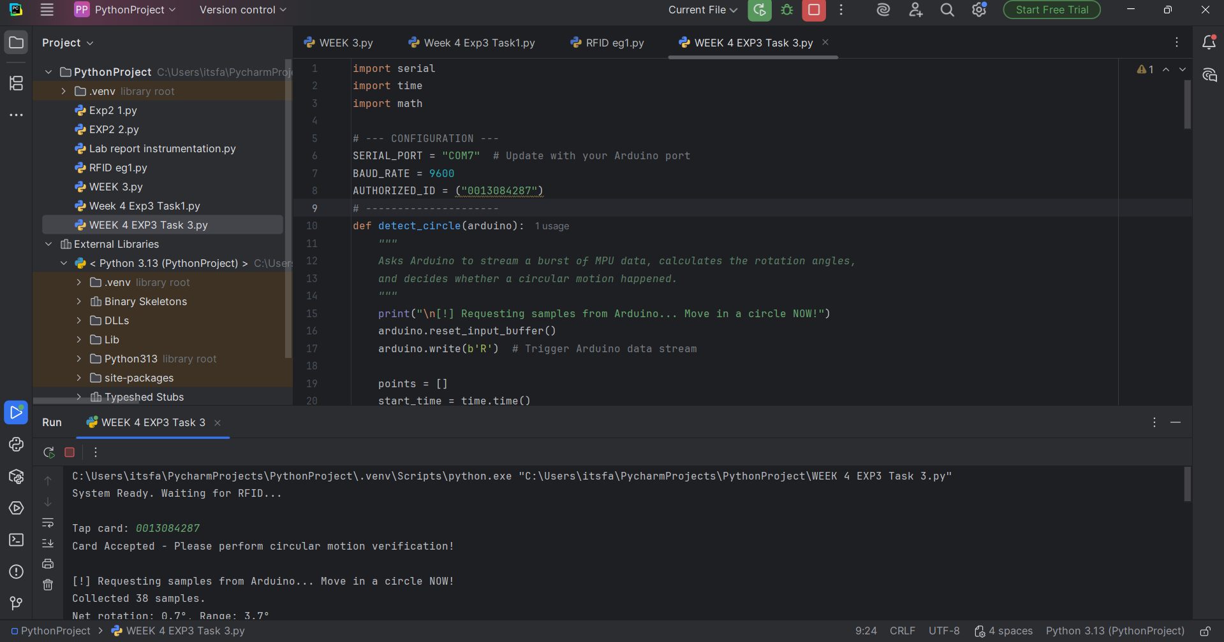
Note: Click on next to the “Tap card:” before tapping the RFID onto the reader.

**Fun activity: Maintain this final connection, but run the Python Script in Task 2, and notice the difference(optional)**

Submission Requirements
- Final Arduino sketch (.ino file)
- Final Python scripts (.py files)
- Brief report (PDF) including:
  - Description of your motion detection approach
  - List of authorized UIDs
  - Integration explanation (how parts work together)
  - Screenshot of working system

Troubleshooting Tips
Issue | Potential Cause & Solution
MPU6050.h: No such file Error in Arduino IDE | You installed the wrong MPU6050 library. Go to Sketch > Include Library > Manage Libraries, search for "MPU6050 Electronic Cats", and install that specific version. Remove any other generic MPU6050 libraries.
PyCharm throws "Access Denied" for the COM Port | The Arduino IDE's Serial Monitor or Serial Plotter is still open. Only one program can use the serial port at a time. Close the IDE monitor and run the Python script again.
RFID Scanner isn't typing anything in PyCharm | The USB RFID scanner acts exactly like a keyboard. You must physically click inside the "Run" terminal window in PyCharm before tapping the card, otherwise, it will type the ID number wherever your mouse last clicked!
Servo Motor is jittering or resetting the Arduino | Servo motors draw a lot of current. Ensure your jumper wires are firmly connected. If the Arduino restarts when the servo moves, power the servo from an external 5V source rather than the Arduino's 5V pin, ensuring you connect the common grounds.

References
- https://lastminuteengineers.com/how-rfid-works-rc522-arduino-tutorial/
What is RFID? How It Works? Interface RC522 RFID Module with Arduino
- https://randomnerdtutorials.com/security-access-using-mfrc522-rfid-reader-with-arduino/
Security Access using MFRC522 RFID Reader with Arduino
- https://randomnerdtutorials.com/arduino-time-attendance-system-with-rfid/
Arduino Time Attendance System with RFID
- https://www.instructables.com/Arduino-MFRC522-RFID-READER/
Arduino + MFRC522 RFID READER

